КИТИМО ЈЕЛКУ
__________________________________________________________________
__________________________________________________________________
__________________________________________________________________
__________________________________________________________________
__________________________________________________________________
__________________________________________________________________
__________________________________________________________________
__________________________________________________________________
__________________________________________________________________
__________________________________________________________________
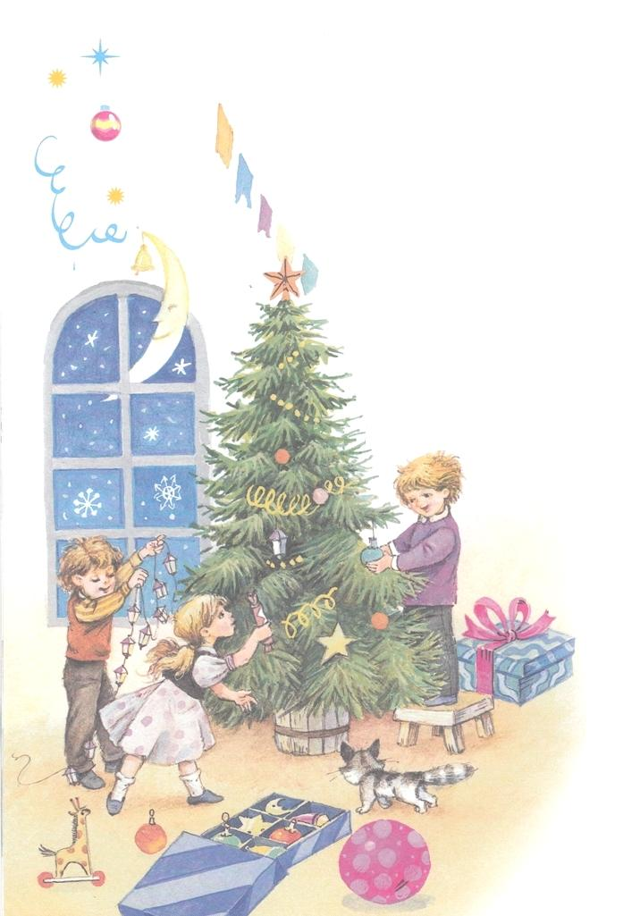м.т

КИТИМО ЈЕЛКУ
__________________________________________________________________
__________________________________________________________________
__________________________________________________________________
__________________________________________________________________
__________________________________________________________________
__________________________________________________________________
__________________________________________________________________
__________________________________________________________________
__________________________________________________________________
__________________________________________________________________
м.т.

