Деда Мраз
______________________________________________________
_________________________________________________________
_________________________________________________________
_________________________________________________________
_________________________________________________________
_________________________________________________________
_________________________________________________________
_________________________________________________________
_________________________________________________________
_________________________________________________________
_________________________________________________________
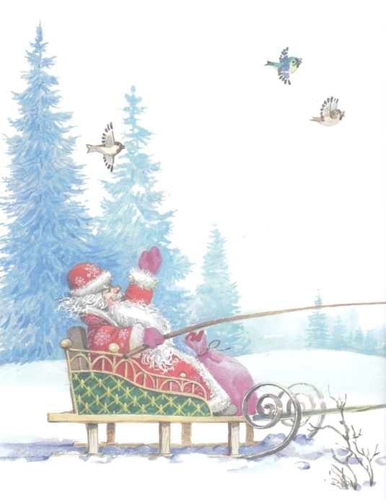

Деда Мраз
____________________________________________________
_________________________________________________________
_________________________________________________________
_________________________________________________________
_________________________________________________________
_________________________________________________________
_________________________________________________________
_________________________________________________________
_________________________________________________________
_________________________________________________________
_________________________________________________________

